Shopify stock visualization-
Data Analysis Report

Submitted by:

Name : Vaisnavi M
Dep : Bsc CS(AI&DS)
Register no :26BSC105

Google colab link:
https://colab.research.google.com/drive/1lgPf2_ZRv8hibPwYwcVP18aOGXUmT_Br?usp=sharing

Introduction
This project focuses on analyzing and visualizing Shopify stock market data using Python. The dataset contains daily stock information including opening price, highest price, lowest price, closing price, adjusted closing price, and trading volume. Data analysis and over time.

Objectives
The main objective of this project is to analyze Shopify stock data and identify important trends and patterns. The project also aims to visualize stock prices and trading volume to make the data easier to understand.

- Visualize historical stock price movements over time.
- Compute and overlay simple moving average (SMA) to smooth out short term noise.
- Analyze the relationship between trading volume , daily price change , and market volatility.

HISTORICAL PRICE TREND
This section shows the closing price movement over time. The closing price line plot indicates the overall market trend. From the chart, it is observed that Gold price was around $1820 in early March, corrected to $1732 in June and then recovered to $1783 in September. This shows a downtrend followed by an uptrend indicating market recovery.
[Insert your closing price line plot here - Section 1 chart]

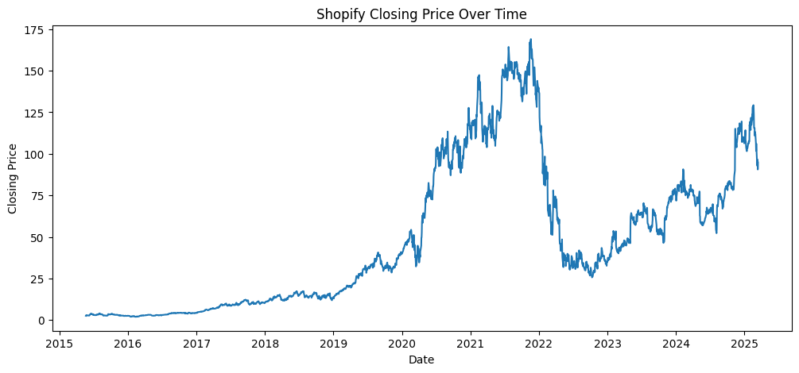
TRADING VOLUME ANALYSIS
Trading volume indicates market participation and liquidity. High volume during price rise indicates strong buying interest. The volume plot shows fluctuations between 1 million to 6 million. Volume spikes are observed during high price movements, which confirms that price changes are supported by volume. Low volume periods indicate consolidation.
[Insert your Volume line plot here - Section 2 chart]

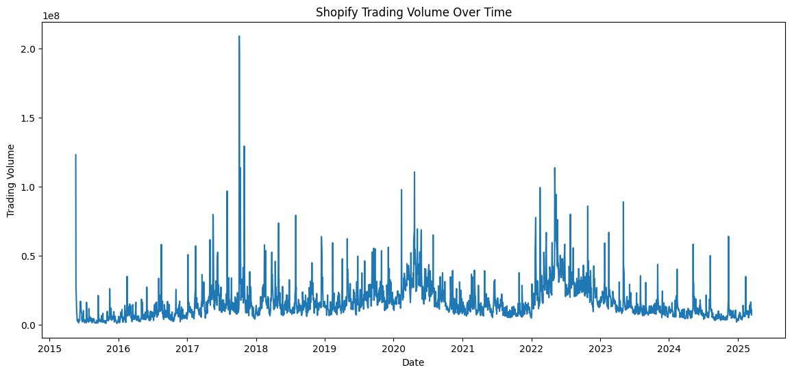
MOVING AVERAGE ANALYSIS
Moving averages smooth out price data to identify trend direction. 20-Day SMA is for short-term trend and 50-Day SMA is for medium-term trend. When 20-Day SMA crosses above 50-Day SMA it is called Golden Cross which is a buy signal. When it crosses below it is Death Cross which is a sell signal. In our analysis, Death Cross occurred in April and Golden Cross occurred in late August indicating bullish momentum for future.
[Insert your Close + 20-Day SMA + 50-Day SMA plot here - Section 3 chart]

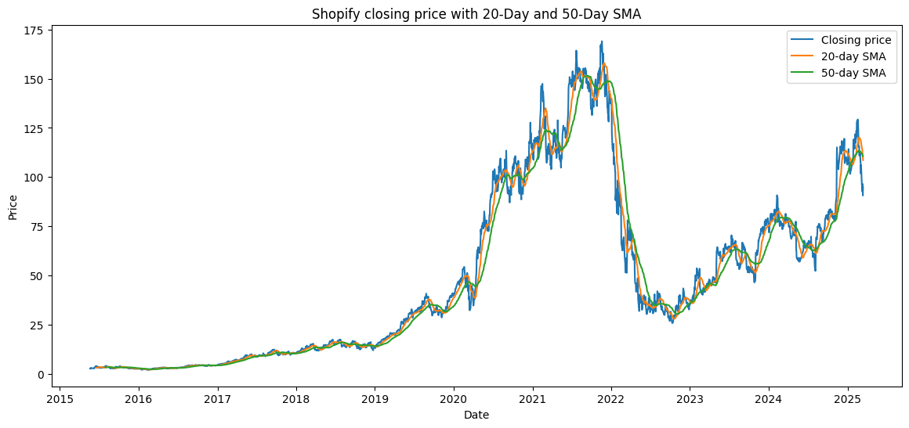
RETURN DISTRIBUTION
Daily Return is calculated as (Close today - Close yesterday)/Close yesterday _ 100. The Histogram + KDE plot shows how returns are distributed. The returns are centered around 0% to 0.1% and most returns are between -0.5% to +0.5%. The distribution is approximately normal, meaning extreme losses are rare. This indicates Gold is relatively stable for daily trading.
[Insert your Histogram + KDE plot here - Section 4 chart- This is the return distribution photo you asked]

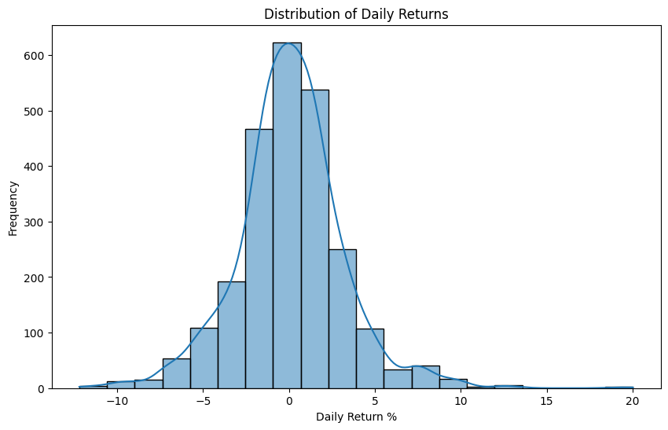
VOLATILITY ANALYSIS
Volatility is measured as rolling 20-day standard deviation of returns. High volatility means high risk. The plot shows volatility between 0.18% to 0.33%. Top 5 high volatility days are identified as early July 2026. These days show high uncertainty and may correspond to market news or global events. Volatility clustering is observed, meaning high volatility days come together.
_[Insert your Volatility plot here - Section 5 chart]

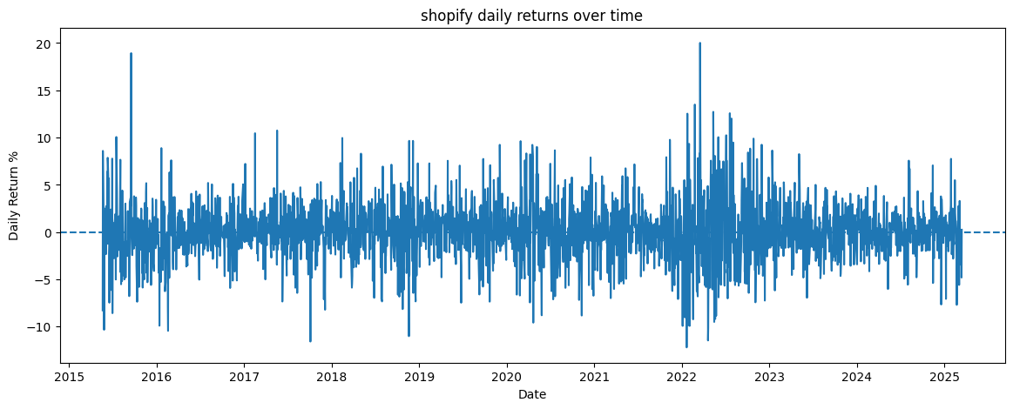

Key Financial Insight

- Revenue Growth – Shows whether the company’s income is increasing or decreasing.
- Profitability – Shows how much profit the company earns after paying its expenses.
- Expense Analysis – Identifies which expenses are high and where costs can be reduced.
- Cash Flow – Shows the amount of cash coming into and going out of the business.
- Debt Level – Shows how much debt the company has and its ability to repay it.
- Liquidity - It shows a company’s ability to pay its short term debts and expenses using its available cash and assets.
Conclusion
The Shopify stock visualization project successfully demonstrates how Python can be used to analyze and visualize financial data. The use of Pandas, Matplotlib, and Seaborn helped in understanding stock price trends, trading volume, and daily price changes. The visualizations provide a simple and effective way to interpret the historical Shopify stock data.

